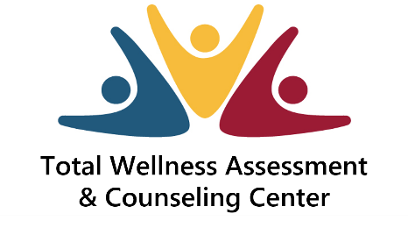
Where we identify the problem and the solution!

Instructions for receiving virtual services
- Download consent forms from via the website at www.totalwellnesscounseling.com
- E-mail the completed forms to twac.health@gmail.com or fax the completed forms to 844-270-8089 at least 24 hours before your scheduled appointment
- Download the Zoom application
- Allow Zoom to have access to your camera
- Complete the brief Zoom sign up process
- Click on the Zoom message sent from your clinician via text message or e-mail at your scheduled time
- At the start of your session, you will be required to pay any financial responsibilities via Venmo or Cashap using twac.health@gmail.com or credit card. Place your full name in the description box
- If you use a credit card, a 10% service fee will be charged.

Additional information

- Please ensure you are in a quiet and private place free from distractions during your appointment
- Missed virtual appointments that are not reschedule or cancelled 24 hrs. in advance will be billed 50.00

